Data Representation: Primitives
im_primitives.php — Information Management

Primitives

Finding and managing data in memory
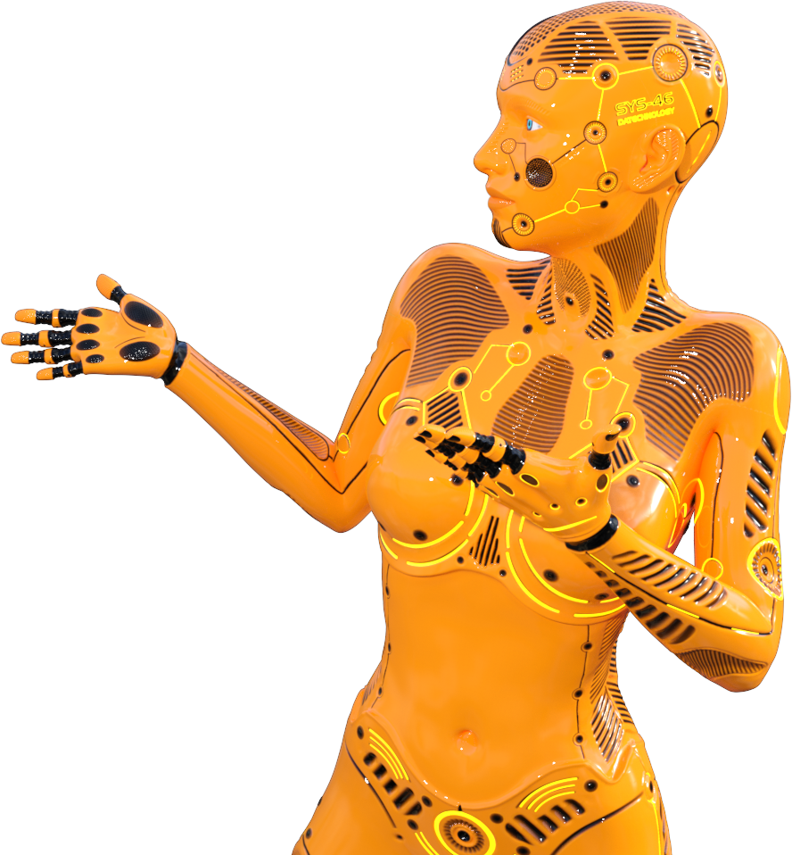
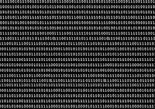
Computer memory is one long sequence of switches.
One long string of '0' and '1' values.
The picture on the left gives you an idea just of how much of a mystery this can be. How would you find your data in that?
Programs (and programmers) have to somehow figure out where in this long sequence their data is.
Luckily the combination of OS and programming language primitive data types makes this easy for us to do.
The OS manages what memory is used by what program (this is one of its functions - see the module on System Software). This means that as a programmer you don't have to know or worry about
where
data is stored in memory (i.e. the address of the data).
The primitive data types that your programming language supports mean that (at least as a beginner programmer) you don't have to worry about
how much memory you need
to store a specific item of data.


Why are they called 'Primitive' data types?
Click the icon in the top right corner of this box to find out.
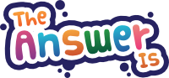
They are the basics that everything is built on…
We call the tools used by our pre-historic ancestors 'primitive' - because they are basic, not sophisticated. A scalpel used in surgery is a much more refined version of the stone knife used to skin prey with and slice up food. But you can see how it is based on that original, primitive tool…
The same applies to the data types provided by your programming language.
The language provides you with the building blocks for storing data in memory - and takes care of managing the process of allocating, freeing and managing memory for the primitives it supplies you with.
This makes the basics of programming easier - and faster to learn.
As you get deeper into programming you might find that you have to develop your own data structures because the primitives do not allow you to work with large, complex groups of data.
So you will end up creating your won data structure - and have do all the hard work of allocating, freeing and managing memory for these data structures as well.
The full range of primitive data types for each language is discussed in the section on Variables in the programming course.
Primitive Data Types
[image unavailable: unknown]
NB: This content should be learnt at the same time as learning about Variables in programming.
Every programming language uses
data types
to make it easier for programmers to store and retrieve elements of data needed by their programs.
These data types are defined as part of the language and create structures that can be used to hold data in memory.
Typically a programmer needs to be able to store:
True / False values
This type of data is usually called a Boolean or Bool. It is used for storing the results of comparisons - and for making decisions. It is often called a flag because you change its value between true and false to let your program make different choices.
Numbers
This type of data is used to store numerical values that can be used for maths and computations.
There are usually several different primitive data types dedicated to numbers - the differences being the size of the largest / smallest number the type allows - and whether the type allows the number to include a decimal point (i.e. fractions).
Text
This type of data is used to store either a single letter or a whole sequence (string) of letters. The data type specifies how the end of the sequence of letters is marked and how many letters can be in the sequence.
Return to the top of this panel
Specific Primitives
[image unavailable: unknown]
Each programming language has a list of primitive data types that you need to learn to use.
There are usually at least THREE primitive data types in a language:
Boolean
Stores only a '0' or a '1' to represent False or True. Used for storing the result of comparisons or decisions.
Number
Many languages have multiple primitives for working with numbers. The types were important in the past when the languages were created. At that time memory size was limited so every byte you could save mattered. CPU's and Operating Systems were also 16 bit - so working with numbers bigger than 16 bits needed complex software workarounds that could slow your program down - you avoided them where possible.
Languages such as Object Pascal (Delphi) and Java keep all these older type primitives around for backwards compatibility.
Now the OS and CPU is 64 bits and using blocks of data smaller than 64 bits is inefficient - that is why modern languages have only one type of primitive for numbers.
String
This type of primitive allows you to work with text.
There are rules in the language saying how much memory the primitive data type uses (usually called 'bytes allocated').
There are also rules in the programming language that specify, for example if a number primitive can hold fractions or negative numbers. For strings the rules specify how long a string can be, how you detect the end of a string, etc.
Return to the top of this panel
Data types in different Languages
[image unavailable: unknown]
Each programming language will call its primitives by a different name (though most are kinda similar) and have small differences in the size and structure of each data type.
To be a
good programmer
you need to
understand the concept of how data is stored and fetched
(explained below in the last part of this section). A
bad programmer only learns the instructions for the language that they are using
.
Each programming language has its own rules for its primitive data types.
If, for example, you as a programmer need to store a number to use later in your program you create a variable of the appropriate data type.
The table below shows you how Delphi, Java, Python and JavaScript provide the programmer with primitives that can store numbers.
If you pay attention, you will see that
Delphi and Java
have a whole lot of types that specify exactly how big (or small) the number can be (this is what is shown in the
Range
column) and whether the number can include a decimal point or not. Each type takes up a different amount of memory (the
Bytes allocated
column)
Javascript does away with all of this and just has one overall number type that handles huge numbers and doesn't care if the number has a decimal point or not.
Python takes things one step further and says that the programmer does not have to worry about types. When you put a value into a variable, Python automatically figures out how best to store that data.
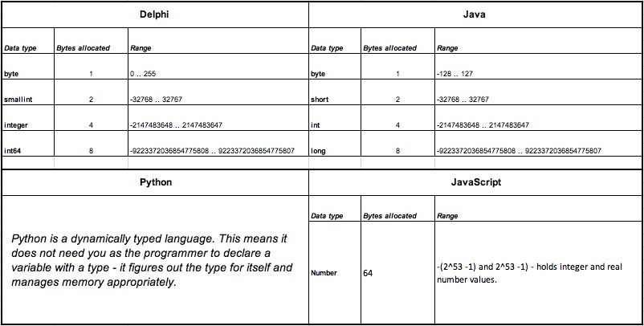
Return to the top of this panel
How Using a Primitive Works…
You declare a variable in your programming language. For example we create the variable "hourlyWage" to hold how much a worker earns per hour.
You specify the type of the variable (unless you are using a language like Python).
Because this data has a decimal point we need a type that can hold fractions.
The worker is not likely to work for a negative amount so we don't need a type that holds signed values (i.e. positive and negative numbers).
The programming language asks the OS for the amount of storage space needed for that variable type (the bytes allocated in the table above).
The program links that memory address to the variable name.
The program creates a table of variable names and addresses that it uses when working with data.
Now when you assign data to that variable or write data to the variable it is simply put into / fetched from the space in memory reserved by the OS.
As you can see, this saves the programmer a lot of hard, tedious work that would have to be done if the programming language did not have primitive data types!
Return to the top of this panel

Video Links - Number Systems (Binary, Hexadecimal, Octal)
We have selected and curated a set of videos on YouTube related to your course.
These videos are not created or owned by us.
They may display advertising and in some cases may contain limited amounts of swearing.

Notes for this Module
What to look out for and do in this module...

FAQs for this module
Questions on Primitive Data Types - and their answers...

Network Types FAQ
View the questions or type in the term you are looking for below…
No results were found

Why do programming languages have Primitives?
To make it easier for us programmers to work with small bits of data.

Why are primitives different but similar in programming languages?
Programmers need to be able to store and manipulate the same basic types of data (true / fasle values; numbers and text).
This is why the primitives are similar.
The names, sizes etc of the primitives in each language differ because different people created the programming languages and different people always have different ideas about what to cal things, how to structure things, etc.

How well do I need to know and understand the Primitives of my programming language?
Well enough that you look at things in the world, think about storing them in a computer program and immediately give them the right primitive data type.
For example:
Light switch. Boolean.
Cold water tap. Number. 0 = closed. 10 = max.
Fridge door. Boolean.
Cup. Number. Number indicates amount of liquid inside in ml.
You need to spend a lot of time doing this kind of exercise. It will help you to think like a computer works…

Do I need to know the Primitives for all programming languages?
No - not really…
When you know and use the primitives for one language you know what to look for in other languages.
The basic concepts are the same - the names, syntax, etc. are what changes between languages.

